**Team Project - Process Analysis and Redesign**

**Syed Farhan Jafri (21L-6074)  
Shaaf Salman (21L-6083)  
Laiba Habib (21L-6102)  
Abdul Hadi (21L-6077)**

**Process Analysis**

**WASTE ANALYSIS**

|  |  |  |
| --- | --- | --- |
| **Step** | **Type of Waste** | **Task Description** |
| 1 | Move | Applicants have to physically go to the bank to submit the fee. |
| 2 | Move, Overproduction, Waiting | Applicants have to wait in long queues to obtain a token number. |
| 3 | Overproduction, Waiting | Applicants have to wait in a queue for photography. |
| 4 | Overproduction, Waiting | Applicants have to face an interview with the interviewing manager, even though the application form includes all the necessary details. |
| 5 | Overproduction, Waiting | Applicants have to face an interview with the interviewing manager, even though the application form includes all the necessary details. |
| 6 | Overproduction, Waiting | Applicants have to wait for a certain number of days to receive their passport. |

**STAKEHOLDER ANALYSIS**

|  |  |  |
| --- | --- | --- |
| **Category** | **Stakeholder** | **Concern** |
| Customer | * Domestic and International Travelers * Foreign Residents | * Timely processing of passport applications and renewals * Accessible and convenient passport application process Reliable and secure passport delivery |
| Process Participants | * Passport office staff * Law enforcement officials | * Efficient and effective processing of passport applications and renewals * Clear and accurate documentation of passport application details * Adherence to passport regulations and security procedures |
| External Parties | * Passport service contractors * Travel agencies and visa service providers * Postal and courier services | * Timely and reliable delivery of passport materials * Accurate and secure handling of passport documents * Adherence to passport regulations and security procedures |
| Process Owner | * Passport office manager * Supervisors | * Timely and accurate processing of passport applications and renewals * Efficient and effective use of resources * Adherence to internal policies and external regulations |
| Sponsor | * National or regional government officials | * The ability of the passport office to contribute to the overall goals of the government, such as security and border control * The ability of the passport office to adapt to changing national and international regulations and policies |

**ROOT-CAUSE ANALYSIS**

**Why-Why Diagram for Long Queue and Processing Times**

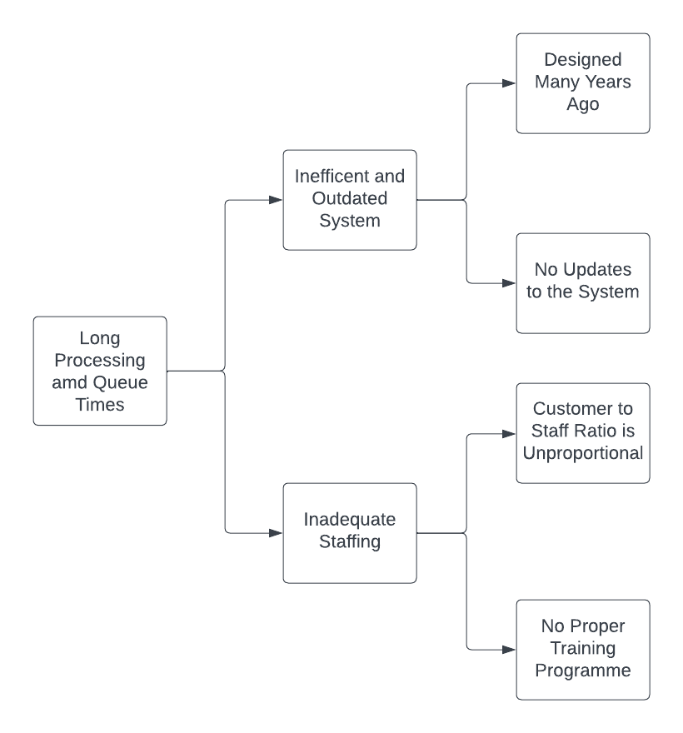

**Cause-Effect/Fishbone Diagram**

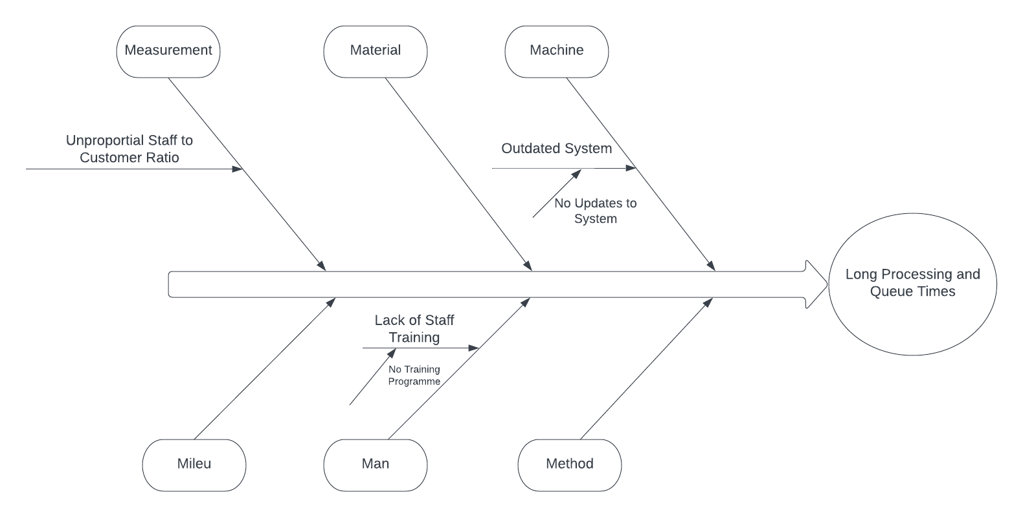

**Process Redesign**

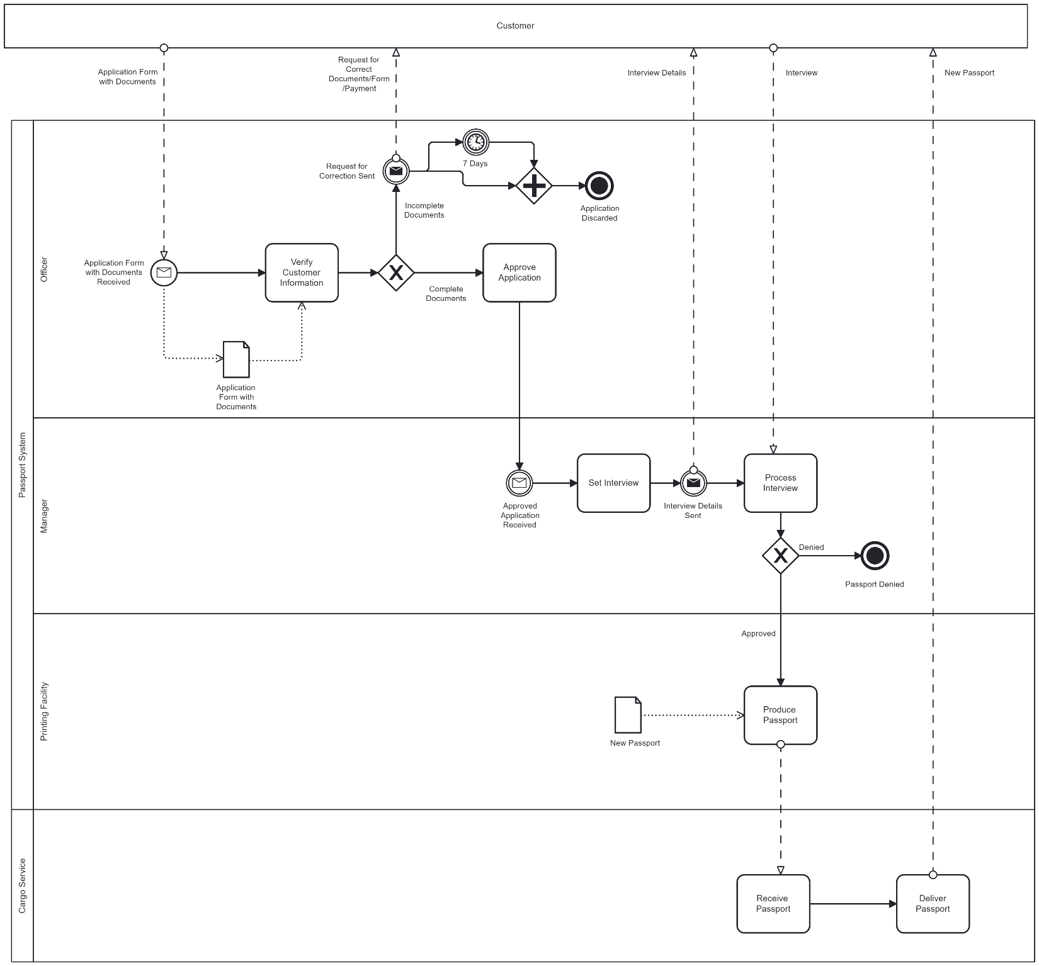**1) New Passport Process**

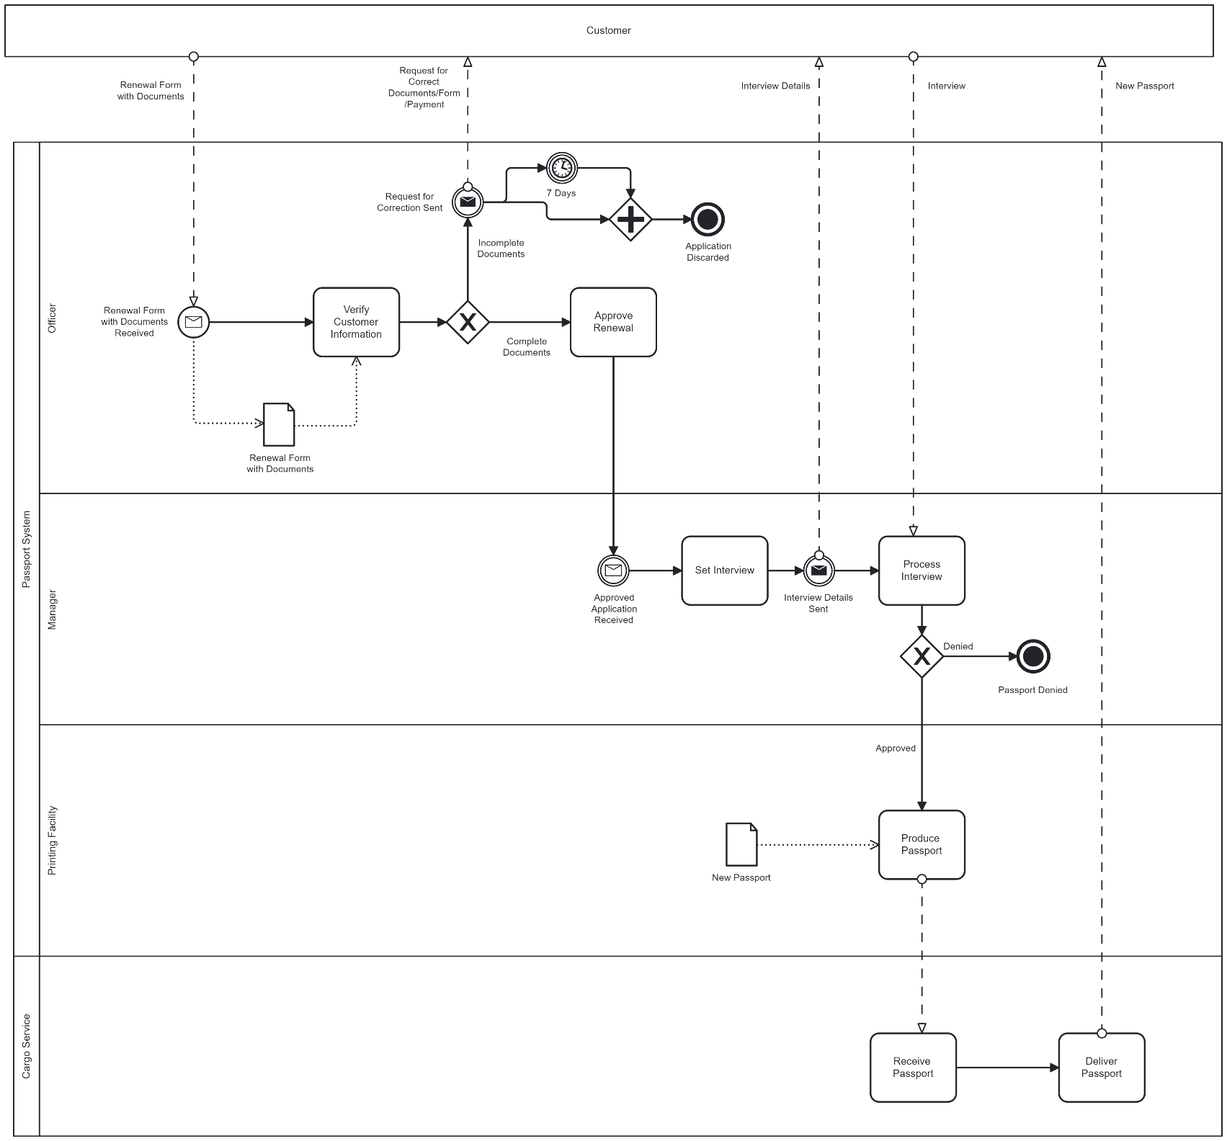**2) Passport Renewal Process**

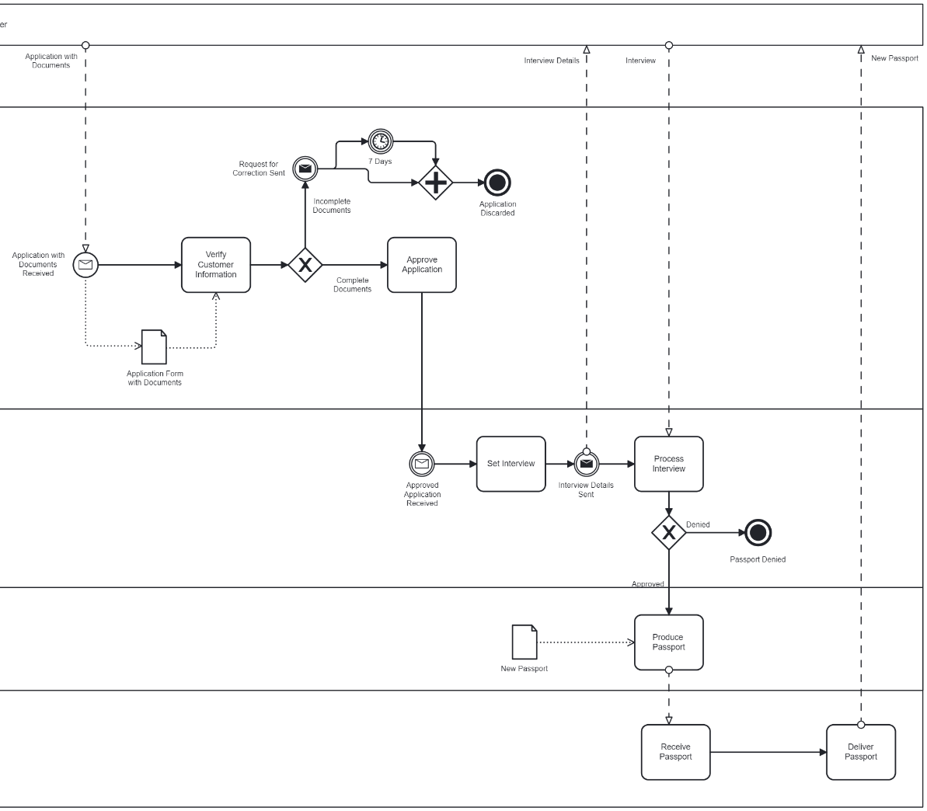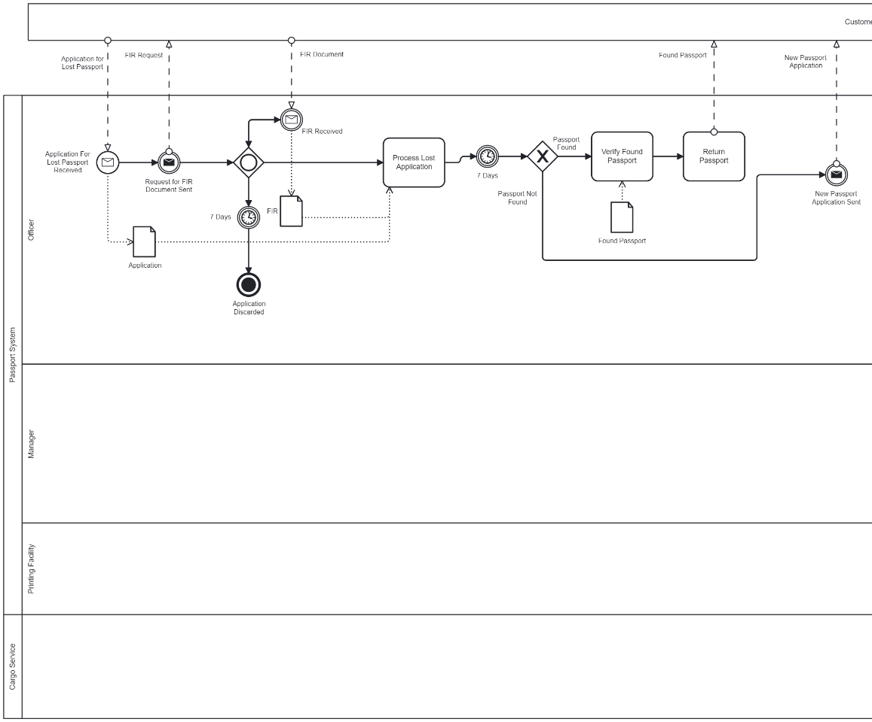**3) Lost Passport Process (could not fit the diagram fully on one page so broke it in half/you can view the whole thing in the bpmn files attached)**

**4) Data Storage Process**

